Using JAXB with ISO 21090 data types
Introduction:
Clients and services in caBIG™communicate through the grid using XML grid communication protocol. To enable this communication, client and server APIs transform objects to and from XML through serialization techniques. caCORE SDK, a common data management framework, uses Castor framework to serialize and deserialize objects while accessing its data services. In order to support ISO 20190 data types, caCORE SDK has to adapt JAXB framework due to a known issue with Castor framework.

This document will summarize current implementation using Castor and an approach to implement it using JAXB.

Current implementation:
The SDK generates various artifacts based on the information that it obtains from the UML model. As part of the code generation process, the caCORE SDK generates XSD and XML mapping files. For each package defined in the object model, the caCORE SDK generates an XSD file. The XSD file is named after the fully qualified name of the package name for which the file was generated. If the UML model is annotated with semantic tags (CDE information from caDSR) then the generated XSD files will include this information as XSD documentation.

The SDK also generates XML mapping files (castor mapping files) for the entire object model. There are two XML mapping files that are generated: xmlmapping.xml and xml-unmapping.xml. These mapping files specify the mapping between every Class and attribute to a corresponding XML entity. These mapping files are of the format specified by Castor, and can be used by the Castor Marshalling framework to marshall between an XML document meeting the corresponding XML schema, and the corresponding Java objects. These files are primarily used by the caGrid project to create a grid service from the SDK generated system.

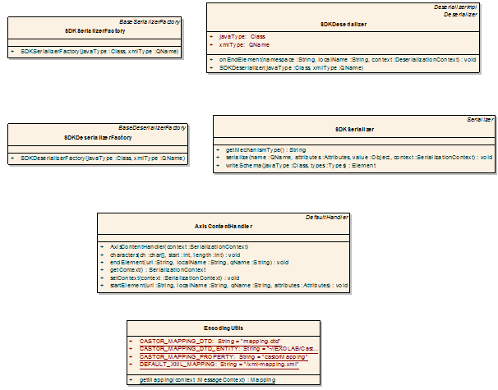

caCORE SDK provides a serialization framework that includes factory and marshalling classes. The Factory classes responsibility is to return an appropriate instance of the Serializer and Deserializer classes as needed. The SDK caCOREMarshaller class implements the SDK Marshaller interface and is used by the XMLUtility class to perform the actual work of marshalling (serializing) domain Java Bean objects to XML. The caCOREMarshaller uses Castor technology, and utilizes the SDK generated xmlmapping.xml file, which provides Java-to-XML binding settings used by the Castor engine.

When processing associations and collections, the caCOREMarshaller also uses custom Castor collection and domain object Field Handlers. This is done in order to prevent infinite recursion whenever domain classes have circular references/associations to each other. Consequently, associations and collections are only serialized to their first level.

Using JAXB:
The Java™Architecture for XML Binding (JAXB) provides a fast and convenient way to bind between XML schemas and Java representations, making it easy for Java developers to incorporate XML data and processing functions in Java applications. As part of this process, JAXB provides methods for unmarshaling XML instance documents into Java content trees, and then marshalling Java content trees back into XML instance documents.

To enable ISO 21090 data types support in caCORE SDK, JAXB implementation must resolve following items:
- Castor functionality should remain in use for marshalling and unmarshaling of data objects using non ISO 21090 data types.
- JAXB implementation should support marshalling and unmarshaling of data objects using ISO 21090 data types and regular datatypes that SDK currently supports.
- JAXB implementation should support integration with caGrid tools.
- JAXB implementation should handle circular references while marshalling data objects.
- JAXB implementation should support collections and object field handlers to handle Hibernate proxies properly.
- JAXB implementation should use existing PODS localized ISO 21090 schema, data objects and serializers to avoid duplication of work.
https://ncisvn.nci.nih.gov/svn/ISO21090/

As a two step approach, JAXB implementation first tackled marshalling and unmarshaling of existing non ISO data types being used by caGrid based applications. Next step is to extend its support to ISO data types using ISO common library. With the implementation of first step, the core JAXB generic implementation procedures and interfaces are finalized. Second step with ISO data types will use the outcome from first step.

Following challenges are addressed in the first step:
- Cyclic reference: If A referring to B and B is referring to A, it would cause cyclic reference during marshalling and unmarshaling process. This has been addressed by implementing JAXB interface (CycleRecoverable). When JAXB identifies any cyclic references, it would use CycleRecoverable implemented method to resolve it.
- Inheritance and associations: JAXB generates POJOs with annotations and bindings when JAXB “xjc” tool is run on a defined XML schema. In the case of SDK generated system, since all the POJOs are autogenerated by SDK codegen from a UML model, all the generated POJOs are created with JAXB annotations and jaxb.index (one of each package) resource file. This will enable core JAXB implementation to create JAXBContext that provides entry point to JAXB API to do marshalling and unmarshaling of inherited or associated objects.
- Hibernate proxies: SDK uses Hibernate proxies to lazy fetch reference data. When the core JAXB implementation try to marshall an object graph, it uses field handlers to ignore hibernate proxies so that they will not generate calls to fetch data. Field handlers are implemented as Adapters using @XmlJavaTypeAdapter JAXB annotation. If a proxy has not been initialized, Adapter will ignore marshalling its contents.

